**Lahore Garrison University**

**DHA Phase 6 Lahore**



|  |  |
| --- | --- |
| **Student Name** | **Muneeb Ur Rehman** |
| **Student Roll No** | **Fa-2023-BSCS-490** |
| **Section** | **D** |
| **Subject** | **Web Technology** |
| **Instructor Name** | **Mr. Muhammad Yousaf** |

**LAB TASK 02**

**Lab 2: HTTP, URLs and Request/Response Basics**

**Objectives:**

* Understand how HTTP works by observing request/response cycles.
* Use browser DevTools and Postman/curl to inspect headers and status codes.
* Simulate caching and status code behavior.

**Tools Required**

* Browser DevTools (Chrome, Firefox, Edge)
* Postman
* Live Server (VS Code extension)

**Step 1:** Inspect HTTP Requests with DevTools

**Procedure**

1. Opened the index.html file using Live Server.
2. Right-clicked → Inspect → selected the Network tab.
3. Reloaded the page (F5) to capture network activity.
4. Clicked on the main request (index.html) to observe details.

**Observation**

|  |  |
| --- | --- |
| **Property** | **Example Value** |
| Request Method | GET |
| Status Code | 200 OK |
| Request Headers | Host: localhost:5500 User-Agent: Chrome/141 |
| Response Headers | Content-Type: text/html; charset=UTF-8 Cache-Control: no-cache |

**Explanation**

* Request Method (GET): Tells the server you’re requesting data.
* Status Code (200 OK): The request was successful.
* Headers: Carry additional information about the request and response (like browser type, content type, etc.).

📸 Screenshot:

Status: Response Header:

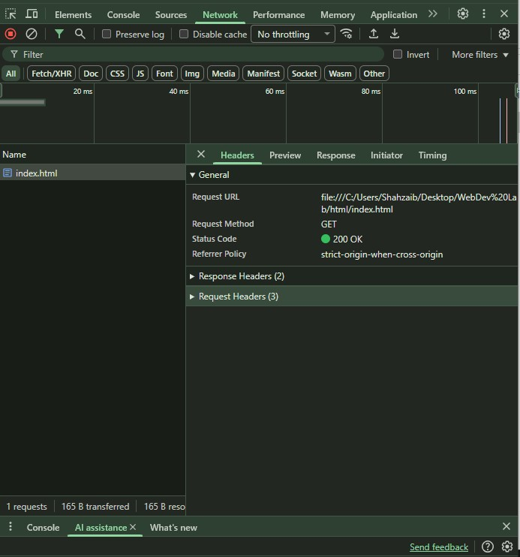

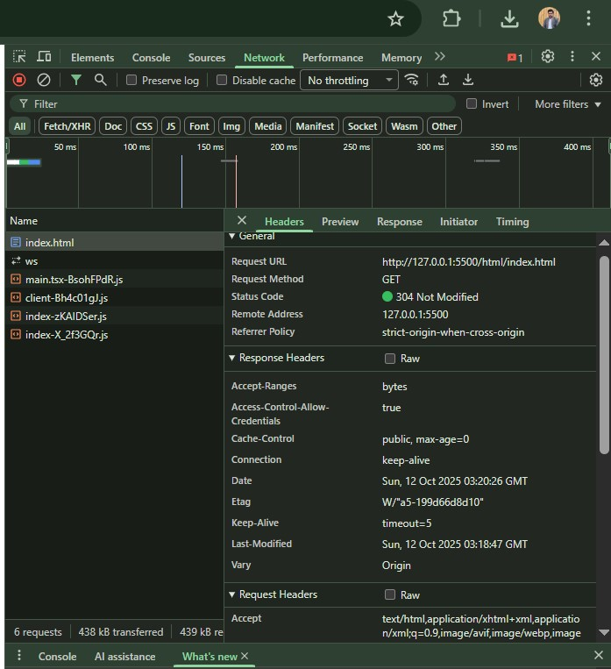

Request Header:

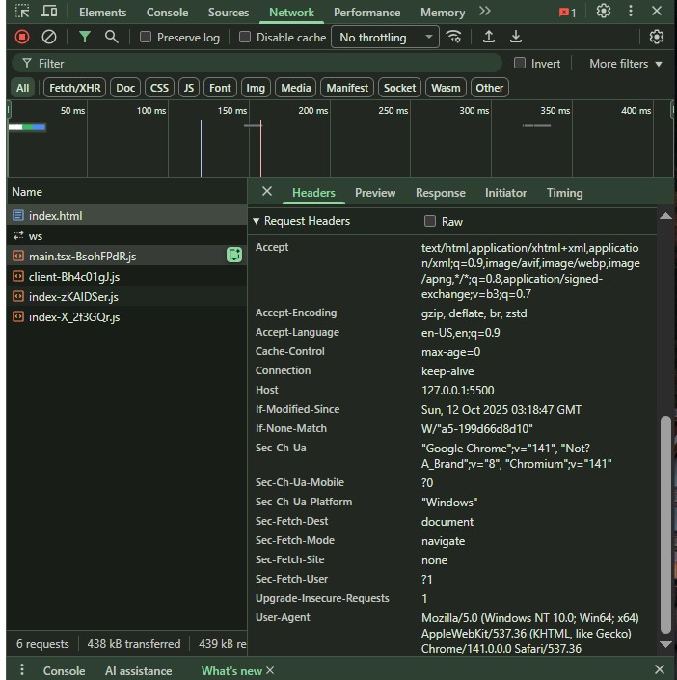

**Step 2**: Make GET and POST Requests with Postman

**(a) GET Request**

URL: http://localhost:5500/index.html  
Method: GET  
Response: Displays the contents of the HTML page.  
Status Code: 200 OK

**Observed Headers:**

* Content-Type: text/html
* Server: Live Server

**Explanation:**  
A GET request retrieves information from the server. The response includes the page data and related headers.

📸 Screenshot:

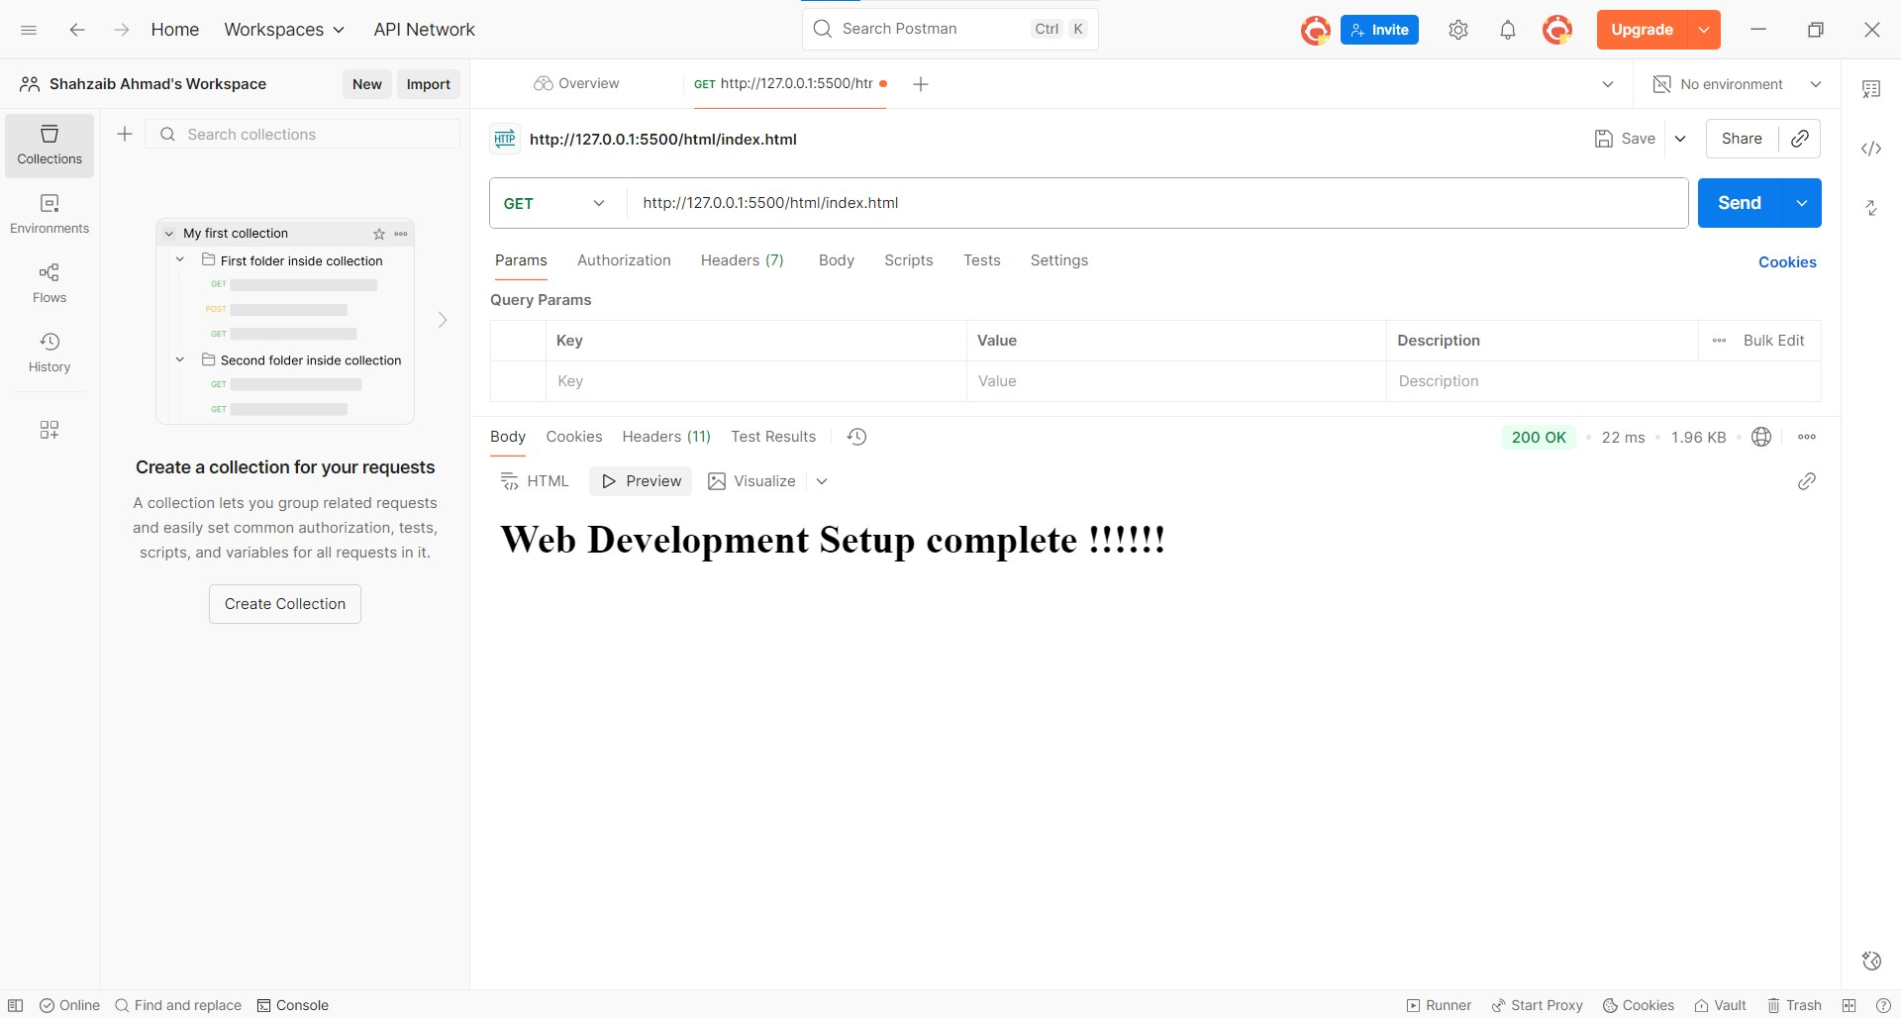

**(b) POST Request**

URL: https://httpbin.org/post  
Method: POST  
**Body (JSON):**

{

"name": "Muneeb Ur Rehman",

"lab": "HTTP Basics",

"Score": 70,

"Passed": True

}

**Headers:**

Content-Type: application/Json

Response Status: 200 OK  
Response Body:  
The server returns the same JSON data confirming that the POST request was received.

**Explanation:**  
A POST request sends data to the server. The server processes the data and returns a confirmation response.

📸 **Screenshot:**

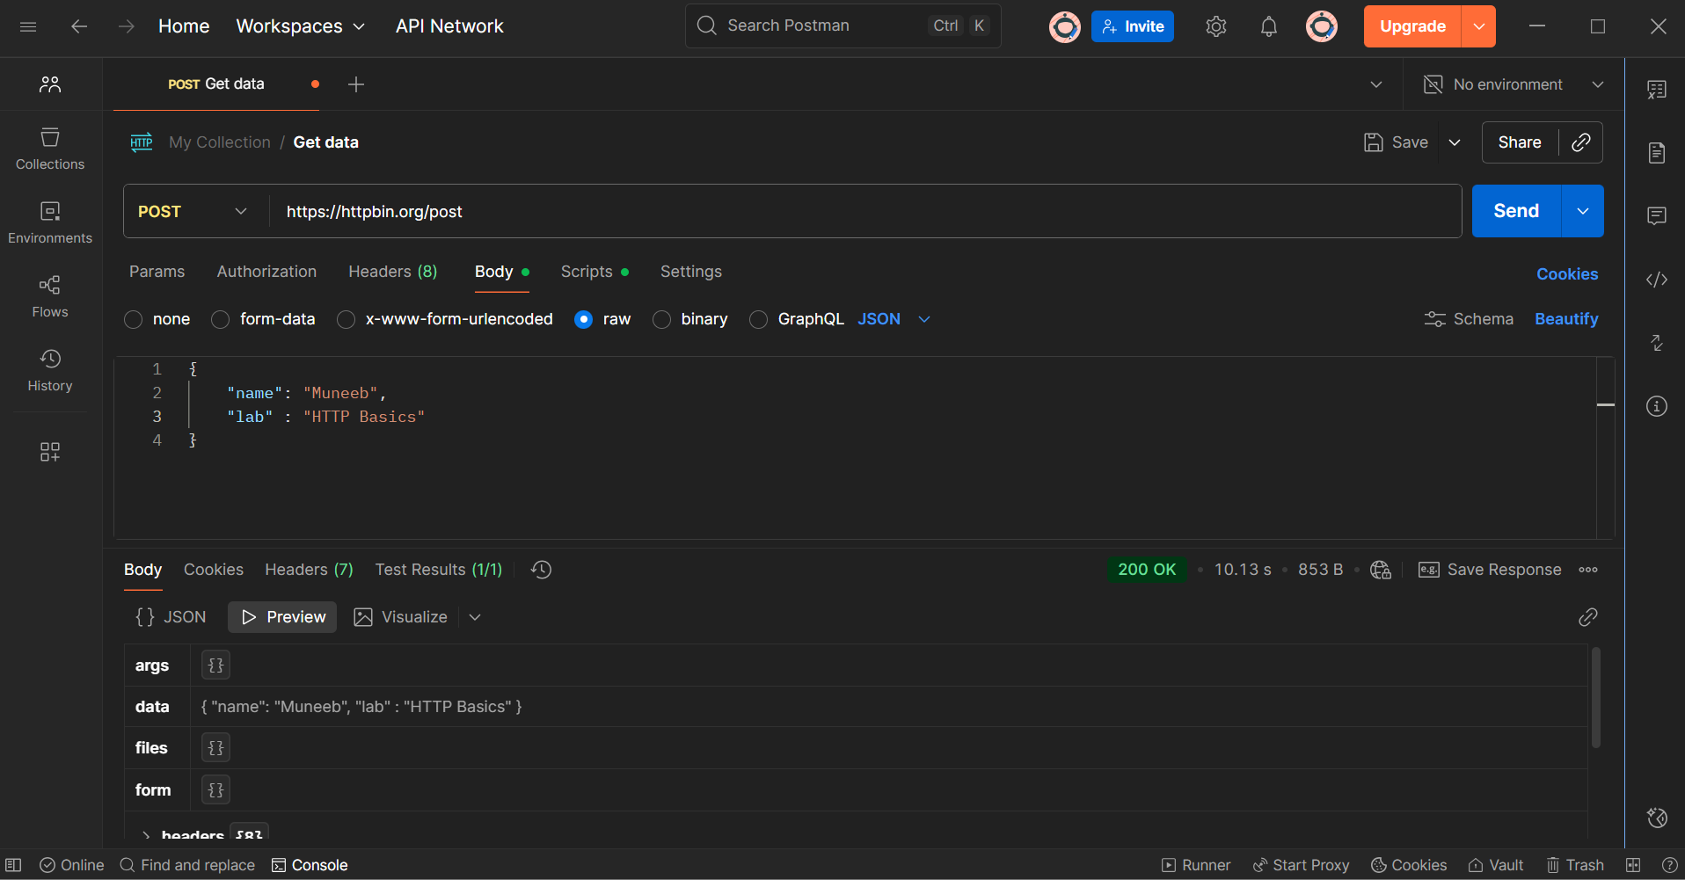

**Step 3:** Simulate Caching and Status Codes

**(a) Caching Simulation**

Code Added in <head> of index.html:

<meta http-equiv="Cache-Control" content="no-cache, no-store, must-revalidate">

<meta http-equiv="Pragma" content="no-cache">

<meta http-equiv="Expires" content="0">

**Observation:**  
After adding these meta tags and reloading the page, the browser no longer used cached data.  
The response headers now include no-cache settings, meaning the browser requests a fresh copy every time.

📸 **Screenshot:**

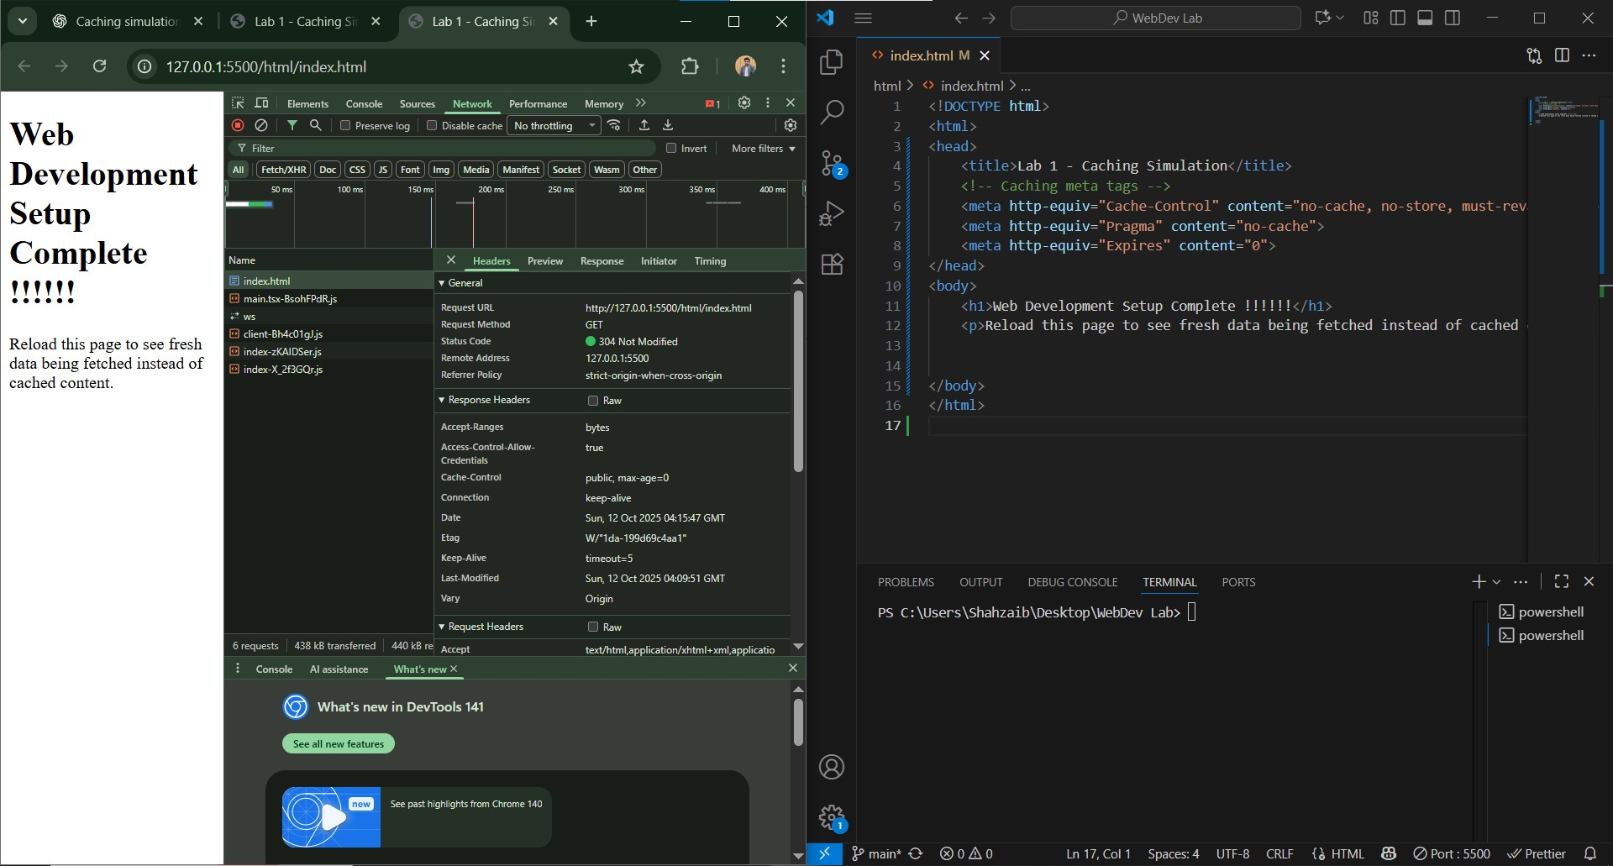

Explanation of Cache Headers:

* Cache-Control: no-cache, no-store, must-revalidate → Disables caching.
* Pragma: no-cache → Used for backward compatibility (HTTP/1.0).
* Expires: 0 → Sets an immediate expiration time for the content.

**(b) Status Code Simulation**

Test URLs Used:

|  |  |  |
| --- | --- | --- |
| URL | Status Code | Description |
| <https://httpbin.org/status/200> | 200 OK | Request successful |
| <https://httpbin.org/status/301> | 301 Moved Permanently | Resource redirected |
| <https://httpbin.org/status/404> | 404 Not Found | Resource does not exist |

**Explanation of Status Codes:**

* 200 OK: The server successfully returned the requested content.

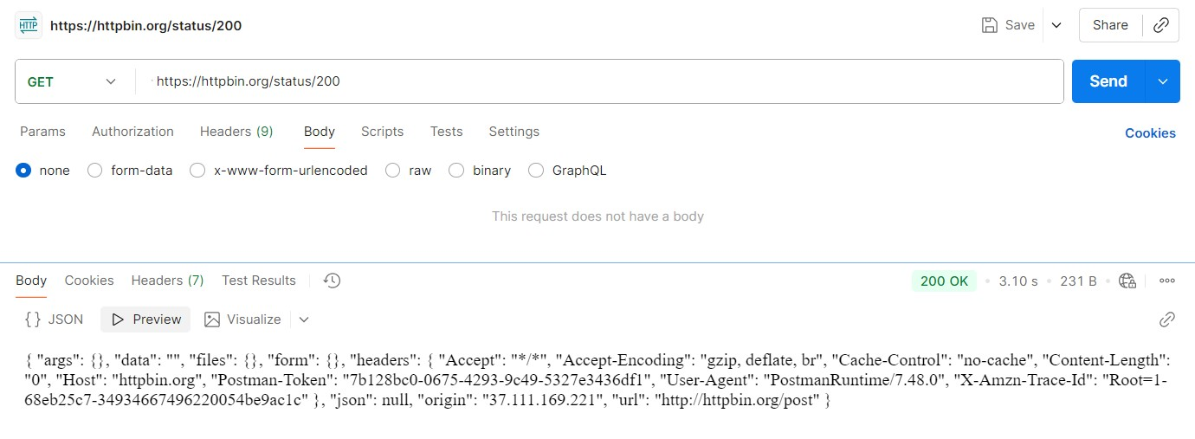

* 301 Redirect: The resource has moved to a new URL permanently.

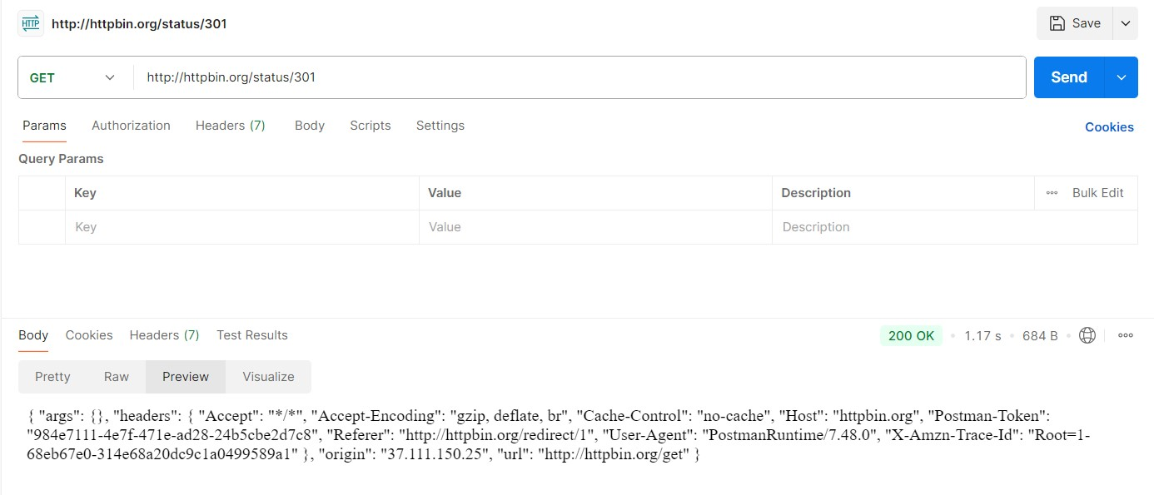

* 404 Not Found: The server couldn’t find the requested resource.

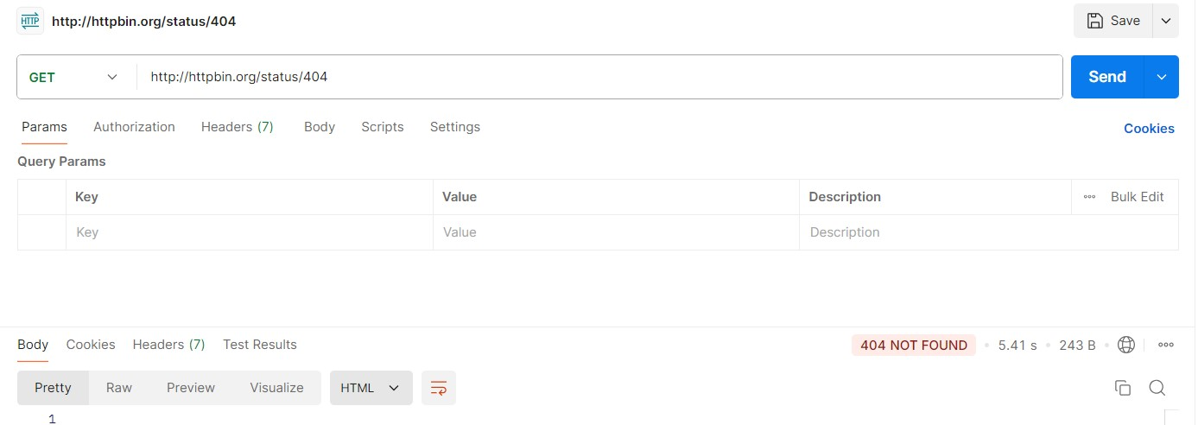

**Step 4:** **Analysis**

Parts of an HTTP Request

1. Request Line: Includes the method (GET, POST) and the requested URL.
2. Request Headers: Provide additional info such as browser type, host, and accepted formats.
3. Body (optional): Contains data sent to the server (used in POST requests).

Parts of an HTTP Response

1. Status Line: Shows status code (e.g., 200, 404).
2. Response Headers: Include metadata about the response (e.g., Content-Type, Cache-Control).
3. Body: Contains the actual content or data returned from the server.

**Step 5:** **Conclusion**

In this lab:

* We successfully inspected HTTP requests and responses using DevTools.
* We created GET and POST requests with Postman.
* We simulated caching and observed changes in response headers.
* We tested multiple HTTP status codes (200, 301, 404) to understand their meanings.

This lab demonstrated the complete request/response cycle and showed how caching and status codes affect web communication.

**RUBRICS:**

|  |  |  |  |  |  |
| --- | --- | --- | --- | --- | --- |
| **Performance** | |  | **Lab Report** | |  |
| **Description** | **Total**  **Marks** | **Marks Obtained** | **Description** | **Total**  **Marks** | **Marks Obtained** |
| **Ability to**  **Conduct practical** | 5 |  | **Structure** | 5 |  |
| **Data Analysis & Interpretation** | 5 |  | **Efficiency** | 5 |  |
| **Total Marks obtained** | |  | **Total Marks Obtained** | |  |

Instructor Signature: -